Food Project

Stack Focus: For this project, I will develop a food-related application using Express and React, offering users a range of features and functionalities centered around food.

Objective: The goal of this project is to offer users valuable food-related information, such as recommendations for food and wine pairings based on price, meal ideas for when they’re unsure of what to cook, food-related jokes, and a feature to search for nearby restaurants.

Type: This project will be developed as a website.

User: The app is accessible to all users, but they must first create an account, which will be stored in a PostgreSQL (PSQL) database. During the registration process, users are required to provide their first name, last name, username, and email.

Design: The scheme of the design is below.

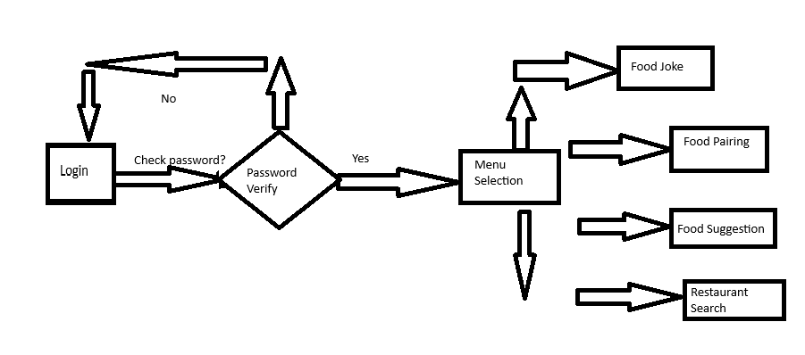

Process: 1) Login

2) Menu Selection

3) Select the functionality